Design Principles

Tyler Anderson

Proximity

Site Name: Woot

<https://www.woot.com/>

I see the design principle Proximity being exemplified on this page (Yes, that’s the home page) because each <p> and element on the page is neatly separated from each other. What I’m mostly noticing is the organization of white space. Further down the page (not shown in the picture) it had a grouping of other items for same. Proximity can also be applied in that respect as well; Content for the current item being sold (in this case an iPad), with the necessary information about it and then other irrelevant information below it.

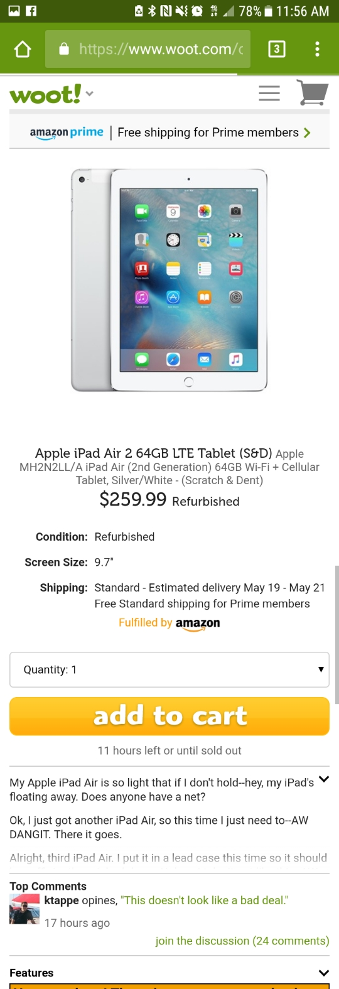

Alignment

Site Name: Grifols

<https://www.grifolsplasma.com/en/web/plasma/home>

Alignment can be seen on this page by noticing the placement of the different text blocks. The blocks are neatly aligned in the center with the text inside either aligned on the left or center, creating an organized look. I considered this website to be under the contrast section but decided to put it under alignment because I preferred the alignment on this page than the other pages that I found. The nav bar at the top is also neatly aligned, allowing equal room for each of the icons to display properly. The overall look of this page is neat. The margins on the sides are noticeable enough so that it doesn’t feel like it’s too big for me to see the content.

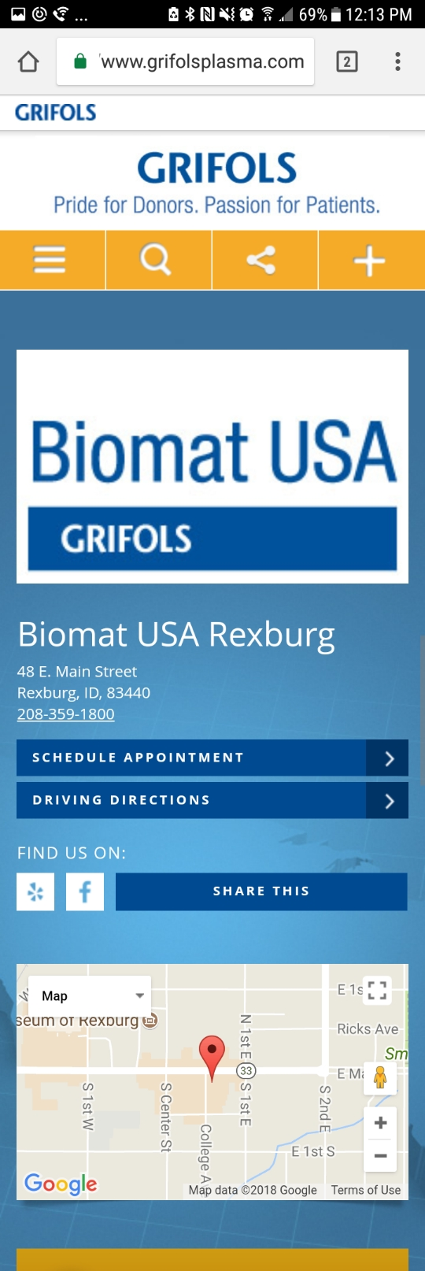

Repetition

Site Name: CheapShark

https://www.cheapshark.com/

This page has repetition written all over it. The general theme throughout the whole page is black, white and orange with the occasional splash of color from different companies. The layout of all the games being sold by a particular site for a certain price is always shown in the same way, at the size. Then there’s the orange button at the bottom of each section allowing the user to browse the games at the linked site. Continuing down the page, it’s the same. More sites with more sales. Lots of repetition.



Contrast

Site Name: The Verge

<https://www.theverge.com/>

The general contrast on this page pops out immediately. The whole page is contrasting. White words on a black background make it different from the usual black and white and seems easier to read. The splotches of color all over the page from the pictures of the different articles easily stand out from the background. The menu item collapsible arrows, the subscripts of the articles (the authors) and outline of the boxes are also a contrasting purple. It’s comfortable to look at and easy to read articles.



Typography

Site Name: Cnet

<https://www.cnet.com/>

A website that epitomized Typography was pretty tough. I went with a site that seemed a little different from the rest of the websites. To be a good website, you need to make your website easily readable. I liked the contrast between the main articles having white text and the sub articles having black text. That could be put in the contrasting principle, but I think it’s also a typology principle. The text on this page wasn’t too thick or thin. It was in a font and size that was comfortable to read. Overall, just... normal.

